We need to do some assumptions at first. First, the battery is not empty at the beginning of every day. Second, we assume that we can behave like an oracle, in other words, we can know that day’s power pattern and solar availability during that day. Third, the period is integer and it can be divided by the execution time T. Forth, the deadline is equal to period.

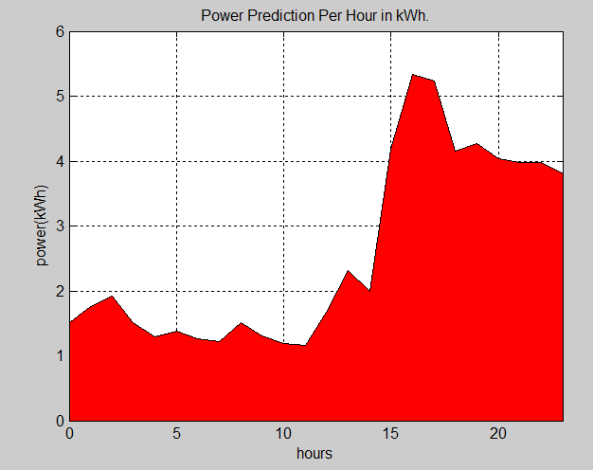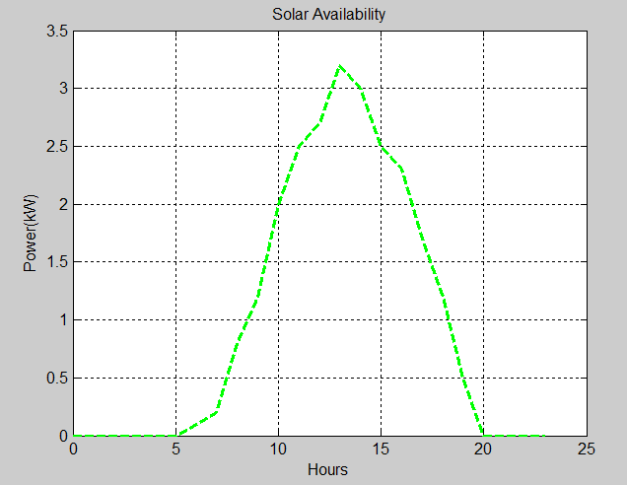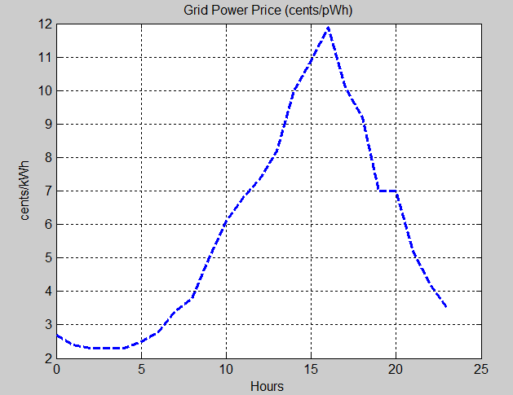

These are the data fundation for the testing and simulation. We choose one day’s data form the data sets. The first one is the power pattern per hour for the whole day. The second one is the solar prediction for that day. In common sence, solar strength during the 12pm and 2 pm is the highest. The third figure plots the electricity grid price per hour for each day according to the electricity market pricing plans which are fixed. Additionally, we choose three appliances in house for deferrable modeling, including Central Air Conditioner, refrigerator and dishwasher. Among them, dishwasher is not pre-emptible. The parameter for each appliance is as following:

ACCentral = [24,24,8,56]

Refrigerator = [2,2,1,0.36]

Dishwasher = [24,24,2,4]

Note [deadine, period, execution time, power per cycle]

**Battery Only Scheculing Simulation:**

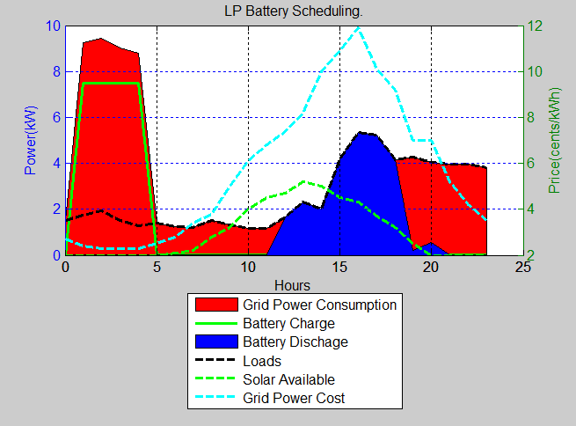This the simulation result for the battery only scheduling which means that we just use battery and grid supply to power the whole home house. The area below the black line is the power demand which has been plotted in the data fundation. The red area is the grid power consumption. From this figure, we can see that, during 0 am and 5am which is the low-cost period based on the grid power pricing plan, we use some grid power to supply for the power demand, the extra grid power is used to charge the battery which will be in turn used during the high-cost period that is blue area in this figure. Under this scheduling, the electricity bill is $2.3 with the battery only , compared with the $4.17 which is the original electricity bill without using the battery. The total cost reduction is up to 44%.

**Battery Solar Scheduling Simulation:**

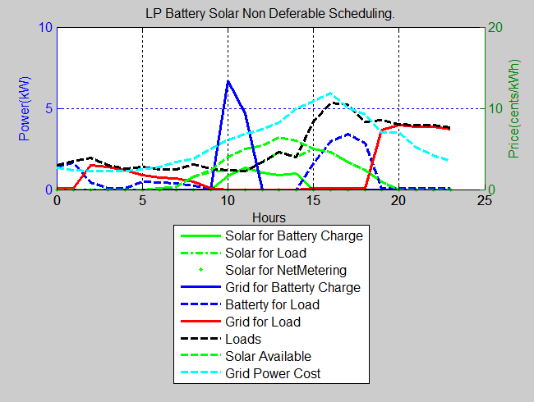In this simulation, we add the solar to the previous power supply group which includes the grid and battery. Compared with the last figure, because we know that in that day, we can use solar availability, we do not need to charge the battery a lot during the night. Instead we use solar to charge the battary during the day when the solar is available. When the peak power demand is coming, the solar and battery both supply electricity power. The resulting electricity bill under this scheduling is $1.98 which is reduced by 52%.

**Battery Solar Plus Workload Scheduling Simulation:**

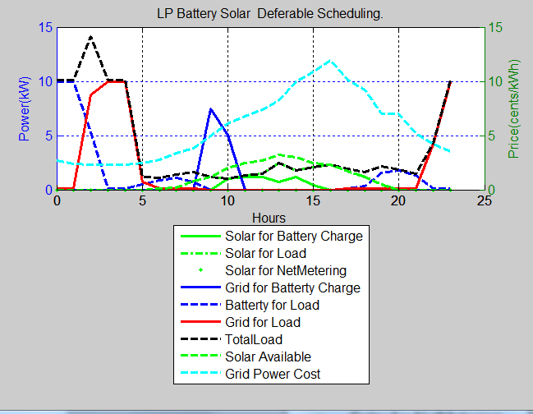Other than battery and solar for supplying, we use the deferrable modeling to schedule the workload as well. From the diagram, the black line which respresents the workload is changed by shifting the deferrable workload to the low-cost period so that getting the bill reduction. This scheduling can save the most which is 54%.